I would build this as if you were building the AI layer of a next-generation contact center, not a complete contact center product. The goal is to demonstrate enterprise AI capabilities while keeping the implementation achievable in 4–8 weeks by a small team.

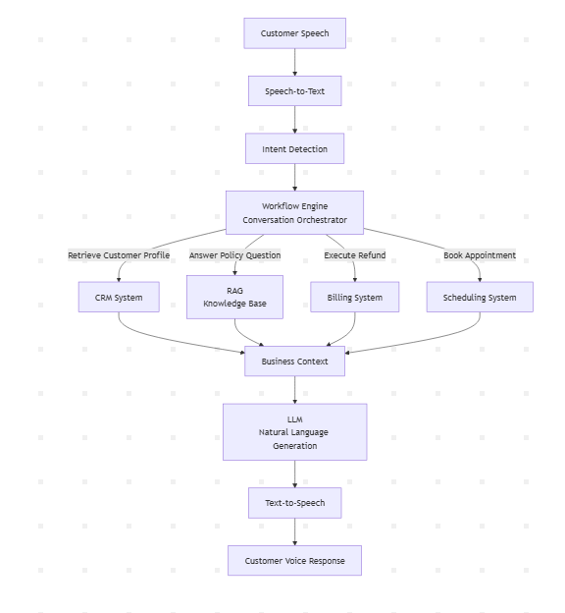

High-Level Architecture

Browser (React)

Click "Start Conversation"
│
WebRTC Audio Stream
│
▼

┌───────────────────────────────┐
│ Session Manager │
│ WebRTC / WebSocket Gateway │
│ Audio Session Management │
└──────────────┬────────────────┘
│
Streaming Audio Chunks
│
▼

┌────────────────────────────────┐
│ Streaming Speech-to-Text │
│ Azure / Deepgram │
└──────────────┬─────────────────┘
│
Partial + Final Transcript
│
▼

┌────────────────────────────────────────────┐
│ AI Agent Orchestrator │
│ │
│ ┌────────────────────────────────────┐ │
│ │ LLM Planner / Reasoning Engine │ │
│ │ │ │
│ │ Decides: │ │
│ │ - What information is needed │ │
│ │ - Which tools to call │ │
│ │ - Whether RAG is required │ │
│ │ - Next conversation step │ │
│ └────────────────────────────────────┘ │
│ │
│ Conversation State │
│ Short-term + Long-term Memory │
│ Context Manager │
│ Intent & Entity Extraction │
│ Tool Orchestrator │
│ Workflow Executor │
│ Policy & Guardrails │
└───────────────┬────────────────────────────┘
│

┌──────────────────┼───────────────────┐
│ │ │
▼ ▼ ▼

┌──────────┐ ┌────────────┐ ┌──────────────┐
│ Tool │ │ Knowledge │ │ Policies & │
│ Calls │ │ Retrieval │ │ Guardrails │
└────┬─────┘ │ RAG │ └──────────────┘
│ └────────────┘
│
┌───────────┼──────────────┬───────────────┬─────────────┐
│ │ │ │ │
▼ ▼ ▼ ▼ ▼

CRM Billing Ticketing Scheduling Other APIs

│
└──────────────────┬──────────────────────┘
│
▼

┌────────────────────────┐
│ Response Generation │
│ LLM + Context │
└───────────┬────────────┘
│
▼

┌────────────────────────┐
│ Streaming Text-to-Speech│
└───────────┬────────────┘
│
▼

Browser Audio Output

Component Breakdown

1. React Frontend
Responsibilities
- Start conversation
- Capture microphone
- Stream microphone over WebRTC
- Play streamed audio
- Show transcript
- Show AI thinking (optional)
- Display ticket number
- Display workflow progress
UI
---------------------------------------

 Connected

Customer:
My internet has been down...

AI:
Checking your account...

Workflow

✓ Customer identified

✓ Outage checked

✓ Booking engineer...

Ticket:
INC-10284

---------------------------------------
This immediately feels like a real enterprise application.

2. Session Gateway
Responsibilities
- Create conversation session
- Authenticate browser
- Maintain WebSocket/WebRTC
- Route audio
- Route events
No AI here.

3. Streaming STT
Recommended
Azure Speech
Outputs
Partial

"My internet..."

Final

"My internet has been down since yesterday."
Don't wait for sentence completion.

4. Conversation Orchestrator (The Brain)
This is the component that differentiates your solution.
It owns
Conversation State

Workflow

Memory

Tool Selection

LLM Calls

Policies

Response Generation
Think of it as an operating system.

Internal Architecture
User Transcript

↓

Intent + Entity Understanding

↓

Business Context Router
|
|
├── Technical Support Context
|
├── Billing Context
|
├── Sales Context
|
└── Complaint Context

↓

Conversation State Update

↓

AI Agent Planner

↓

Dynamic Execution Plan

↓

┌───────────────┬──────────────┬──────────────┐
│ │ │
Tools RAG Human Escalation
│ │ │
CRM/API Knowledge Agent Queue

↓

Response Generation

↓

TTS

Conversation State
Instead of storing only messages
messages[]
Maintain
{
"session":"abc",

"customer_verified":true,

"customer_id":"12345",

"intent":"internet_issue",

"router_restarted":true,

"ticket_created":false,

"engineer_booked":false,

"sentiment":"frustrated",

"workflow_step":"check_outage"
}
Every component reads this.

Memory
Three layers.

Working Memory
Current workflow
Router restarted

Internet down

No outage

Checking signal

Conversation Memory
Entire transcript
Customer:
...

AI:
...

Long-term Memory
Optional
Previous calls
Last month

Engineer visited

Customer premium

Previous complaint

Intent Detection
Use LLM.
Possible intents
Refund

Complaint

Technical Support

Sales

Billing

Password Reset

General Question
Confidence below threshold
↓
Ask clarification.

Workflow Engine
Each intent maps to a workflow.
Example
Technical Support

↓

Authenticate

↓

Check Account

↓

Check Outage

↓

Run Diagnostics

↓

Book Engineer

↓

Create Ticket

↓

Confirmation
Represent workflows as YAML or JSON rather than hard-coding them, making it easy to add new business processes.

Tool Layer
Every enterprise capability is exposed as a tool.
Example
lookup_customer()

check_outage()

restart_router()

book_engineer()

create_ticket()

lookup_invoice()

cancel_order()

refund_payment()

send_email()

send_sms()
Initially
Implement as FastAPI mocks.
Later
Replace with SAP/CRM APIs.

RAG
Use RAG only for knowledge.
Questions like
What is your refund policy?

How long is warranty?

What documents are needed?
Don't use RAG for
Refund my payment.

Book engineer.

Cancel order.
Those use tools.

Policy Engine
Simple rules.
Refund > ₹10,000

↓

Manager approval
Customer angry

↓

Escalate
Three failed diagnostics

↓

Engineer visit
Keeps the LLM from inventing business rules.

Response Generator
The LLM receives structured context.
Example prompt
Intent:
Technical Support

Current Step:
Book Engineer

Customer:
Premium

Ticket:
INC-1023

Tool Result:
Engineer available tomorrow

Respond politely.
This produces much more consistent responses than prompting from raw transcripts.

Streaming TTS
Azure Speech
Return audio immediately.
No waiting for full paragraphs.

Human Handoff
Generate
Conversation Summary

Customer

Verified

Intent

Technical Support

Diagnostics Completed

Router restarted

Signal weak

Engineer booked

Tomorrow 10 AM

Ticket

INC-1023

Sentiment

Frustrated
A live agent could continue seamlessly.

Observability
Log every step:
Intent detected

Workflow selected

Tools called

Latency

Tokens

Errors

Hallucination guardrail

Cost
This is invaluable during demos and development.

Suggested Demo Scenarios
Implement three complete workflows rather than dozens of partial ones.

1. Technical Support
- Customer reports internet issues.
- Authenticate.
- Check outage.
- Run diagnostics.
- Book engineer.
- Create ticket.
Shows workflow orchestration and tool calling.

2. Billing & Refund
- Customer requests a refund.
- Verify eligibility.
- Check payment.
- Trigger refund.
- Send confirmation.
Shows business rules and API orchestration.

3. Knowledge & Policy
Customer asks:
"What's your cancellation policy?"
Uses RAG with citations.
Shows the difference between knowledge retrieval and transaction execution.

Other Test cases
"My internet has been slow for the past week, I was billed extra this month, and I am thinking of cancelling because this keeps happening."
- "I was charged twice for my last payment, my service is still not active, and I need this fixed before tomorrow."
- "I want to upgrade my plan because my current one is too slow, but I also noticed an unexpected charge on my latest bill."
- "My delivery is delayed, I was promised it would arrive yesterday, and I want to know if I can get a refund."
- "I cancelled my subscription last month, but I was charged again today and I want my money back."
Recommended Technology Stack
Layer | Technology
Frontend | React + TypeScript
Audio | WebRTC
Streaming Transport | WebSocket
Backend | FastAPI
Orchestration | LangGraph
LLM | GPT-5.5 (tool calling enabled)
STT | Azure Speech
TTS | Azure Speech
RAG | Azure AI Search (or FAISS for local demos)
Mock Enterprise APIs | FastAPI microservices
Session State | Redis
Persistent Storage | PostgreSQL
Vector Store | Azure AI Search / pgvector
Logging | OpenTelemetry + Langfuse

Why this architecture works
The architecture intentionally separates conversation, reasoning, and business execution:
- Speech services handle audio only.
- The Conversation Orchestrator owns state, memory, and workflow progression.
- The LLM is used for understanding, planning within constraints, and natural-language generation—not for executing business logic.
- Tools perform deterministic actions against enterprise systems.
- RAG answers knowledge questions, while tools execute transactions.
- Policies enforce business and compliance rules before actions are taken.
This mirrors the design principles used in production AI contact centers while remaining compact enough for a demo. More importantly, every major AI capability—streaming conversation, memory, orchestration, tool use, retrieval, and workflow automation—is visible to the audience, making it a strong showcase of enterprise AI rather than just another voice chatbot.

